CS412 HW3 Report: Logistic Regression Model Evaluation
Sezer Enis Birgili
31033

Introduction
In this report, we present the results obtained from training and evaluating a logistic regression model on a dataset. The aim was to classify instances into two classes based on input features.

Dataset
The dataset consists of features and labels for classification tasks. The dataset named titanicdata contains the features Pclass, Sex, and Age. The label of the dataset is the binary classification value of survived featured in the titanicdata csv. Features are represented as numerical values, and labels indicate the class to which each instance belongs.

Model Training
We split the dataset into training, validation, and testing sets, with 60%, 20%, and 20% of the data allocated to each, respectively. The features were scaled using StandardScaler to linearly scale them within the 0-1 range. We then trained the logistic regression model using different combinations of hyperparameters, including step size (learning rate) and number of iterations.

Validation Loss Curves
Figures 1 through 5 shows the validation loss curves for different numbers of iterations. Each subplot corresponds to a different number of iterations, and each curve represents the validation loss across iterations for a specific step size. The final 6th figure is the validation curve with the best hyperparameters with the least amount of loss.

Based on the validation loss curves, we selected the hyperparameters that resulted in the lowest validation loss. The chosen hyperparameters were a step size (learning rate) of 0.1 and 200 iterations.

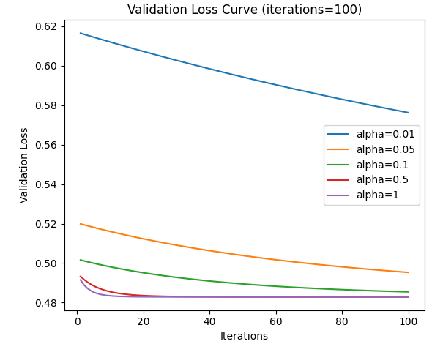
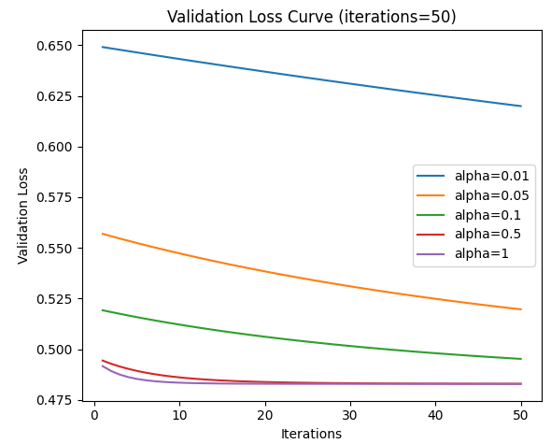
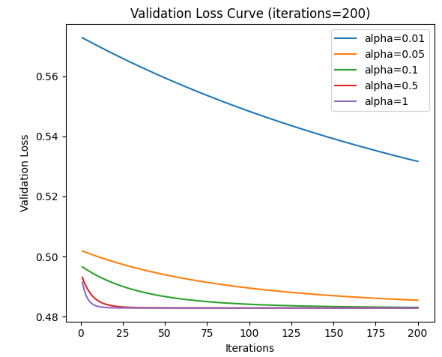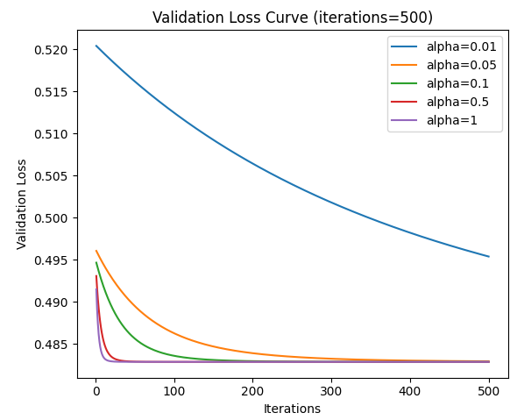 Figure-1 Validation Curves for 50 iterations Figure-2 Validation Curves for 100 iterations

Figure-3 Validation Curves for 200 iterations Figure-4 Validation Curves for 500 iterations
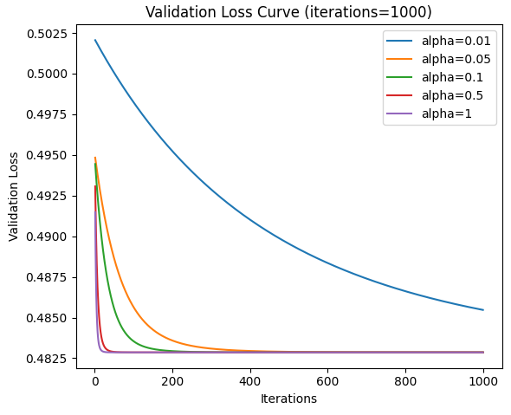

Figure-5 Validation Curves for 1000 iterations
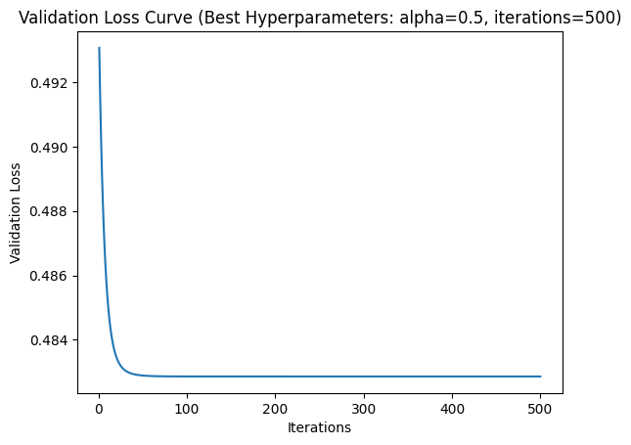
Figure-6 Best Validation Curve with Best Hyperparameters

Final Model Evaluation
We combined the training and validation data and retrained the final model using the chosen hyperparameters. The trained model was then evaluated on the testing data to assess its performance. After the training process, the accuracy of the final model on the testing data was found to be 0.85, indicating that 85% of the instances in the testing set were correctly classified by the model. In conclusion, the logistic regression model performed reasonably well on the given dataset, achieving an accuracy of 85% on the testing data.

